Catalyst Spa - Website Mockup Corrections
THEME 2
1. Remove theme name from the following sections. Replace with Catalyst Spa or any suitable word.
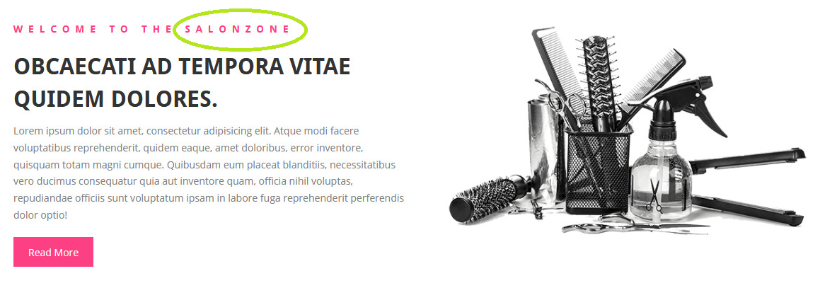

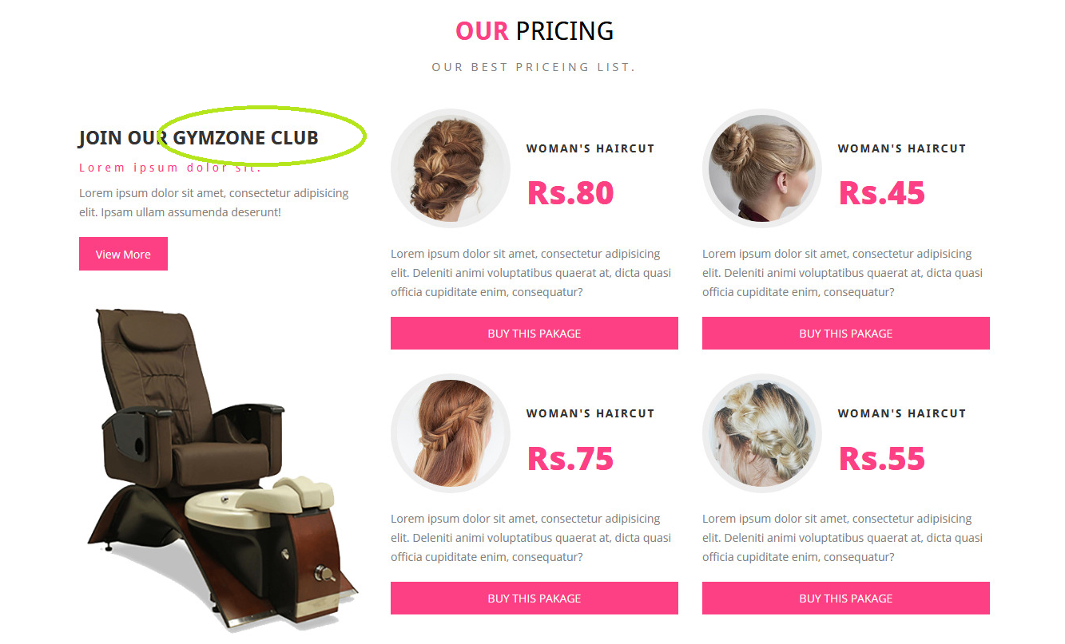

2. Remove the photo from the following section. replace with any suitable image related to ladies.
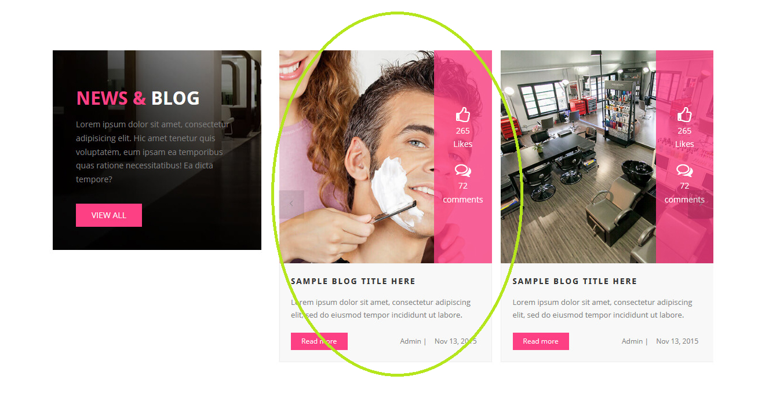

3. Remove these 3 links from the footer. Add suitable terms related to beauty or spa or Menu links
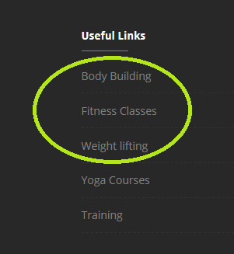

THEME 3
1. Replace ' Website' with 'Spa'. Also remove theme name from the banner section
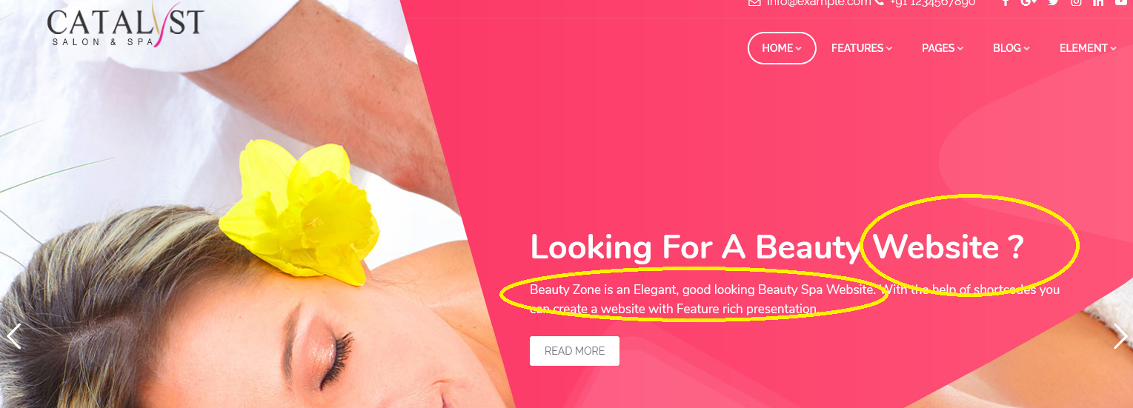

2. Replace the blank space with map
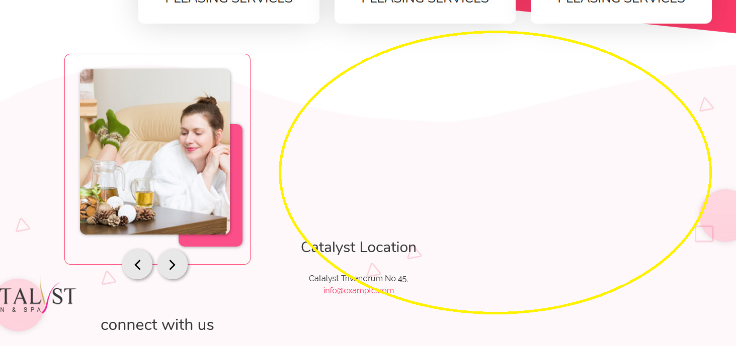
3.Replace 'Theme' with 'Spa'
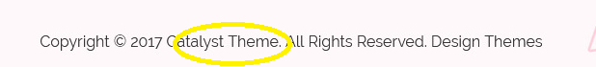
! Remove theme name from all 3 Mockups

